Agentic AI – Course by Hugging Face

An Agent is a system that leverages an AI model to interact with its environment in order to achieve a user-defined objective. It combines reasoning, planning, and the execution of actions (often via external tools) to fulfill tasks

Think of the Agent as having two main parts:
- The Brain (AI Model)
This is where all the thinking happens. The AI model handles reasoning and planning. It decides which Actions to take based on the situation.
- The Body (Capabilities and Tools)
This part represents everything the Agent is equipped to do.
The scope of possible actions depends on what the agent has been equipped with. For example, because humans lack wings, they can’t perform the “fly” Action, but they can execute Actions like “walk”, “run” ,“jump”, “grab”, and so on.
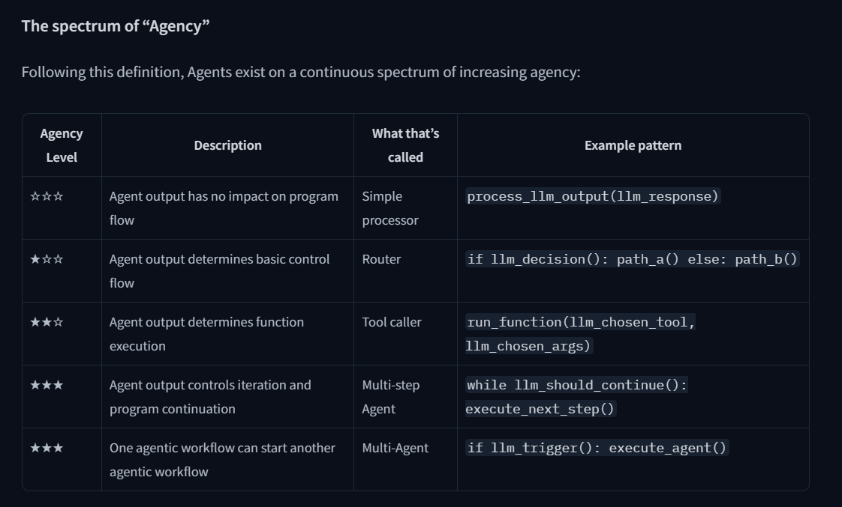

What type of AI Models do we use for Agents?
The most common AI model found in Agents is an LLM (Large Language Model), which takes Text as an input and outputs Text as well.
Well known examples are GPT4 from OpenAI, LLama from Meta, Gemini from Google, etc. These models have been trained on a vast amount of text and are able to generalize well. We will learn more about LLMs in the next section.
It's also possible to use models that accept other inputs as the Agent's core model. For example, a Vision Language Model (VLM), which is like an LLM but also understands images as input. We'll focus on LLMs for now and will discuss other options later.

What type of tasks can an Agent do?
An Agent can perform any task we implement via Tools to complete Actions.
For example, if I write an Agent to act as my personal assistant (like Siri) on my computer, and I ask it to “send an email to my Manager asking to delay today’s meeting”, I can give it some code to send emails. This will be a new Tool the Agent can use whenever it needs to send an email. We can write it in Python:
Copied
def send_message_to(recipient, message):
"""Useful to send an e-mail message to a recipient"""
...
The LLM, as we’ll see, will generate code to run the tool when it needs to, and thus fulfill the desired task.
Copied
send_message_to("Manager", "Can we postpone today's meeting?")
The design of the Tools is very important and has a great impact on the quality of your Agent. Some tasks will require very specific Tools to be crafted, while others may be solved with general purpose tools like “web_search”.
Note that Actions are not the same as Tools. An Action, for instance, can involve the use of multiple Tools to complete.
Allowing an agent to interact with its environment allows real-life usage for companies and individuals.

Example 1: Personal Virtual Assistants
Virtual assistants like Siri, Alexa, or Google Assistant, work as agents when they interact on behalf of users using their digital environments.
They take user queries, analyze context, retrieve information from databases, and provide responses or initiate actions (like setting reminders, sending messages, or controlling smart devices).

Example 2: Customer Service Chatbots
Many companies deploy chatbots as agents that interact with customers in natural language.
These agents can answer questions, guide users through troubleshooting steps, open issues in internal databases, or even complete transactions.
Their predefined objectives might include improving user satisfaction, reducing wait times, or increasing sales conversion rates. By interacting directly with customers, learning from the dialogues, and adapting their responses over time, they demonstrate the core principles of an agent in action.

Example 3: AI Non-Playable Character in a video game
AI agents powered by LLMs can make Non-Playable Characters (NPCs) more dynamic and unpredictable.
Instead of following rigid behavior trees, they can respond contextually, adapt to player interactions, and generate more nuanced dialogue. This flexibility helps create more lifelike, engaging characters that evolve alongside the player’s actions.

To summarize, an Agent is a system that uses an AI Model (typically an LLM) as its core reasoning engine, to:
- Understand natural language: Interpret and respond to human instructions in a meaningful way.
- Reason and plan: Analyze information, make decisions, and devise strategies to solve problems.
- Interact with its environment: Gather information, take actions, and observe the results of those actions.

What is a Large Language Model?
An LLM is a type of AI model that excels at understanding and generating human language. They are trained on vast amounts of text data, allowing them to learn patterns, structure, and even nuance in language. These models typically consist of many millions of parameters.
Most LLMs nowadays are built on the Transformer architecture—a deep learning architecture based on the “Attention” algorithm, that has gained significant interest since the release of BERT from Google in 2018.

There are 3 types of transformers:
- Encoders
An encoder-based Transformer takes text (or other data) as input and outputs a dense representation (or embedding) of that text.
  - Example: BERT from Google
  - Use Cases: Text classification, semantic search, Named Entity Recognition
  - Typical Size: Millions of parameters
- Decoders
A decoder-based Transformer focuses on generating new tokens to complete a sequence, one token at a time.
  - Example: Llama from Meta
  - Use Cases: Text generation, chatbots, code generation
  - Typical Size: Billions (in the US sense, i.e., 10^9) of parameters
- Seq2Seq (Encoder–Decoder)
A sequence-to-sequence Transformer combines an encoder and a decoder. The encoder first processes the input sequence into a context representation, then the decoder generates an output sequence.
  - Example: T5, BART
  - Use Cases: Translation, Summarization, Paraphrasing
  - Typical Size: Millions of parameters
Although Large Language Models come in various forms, LLMs are typically decoder-based models with billions of parameters. Here are some of the most well-known LLMs:
There are 3 types of transformers:
- Encoders
An encoder-based Transformer takes text (or other data) as input and outputs a dense representation (or embedding) of that text.
  - Example: BERT from Google
  - Use Cases: Text classification, semantic search, Named Entity Recognition
  - Typical Size: Millions of parameters
- Decoders
A decoder-based Transformer focuses on generating new tokens to complete a sequence, one token at a time.
  - Example: Llama from Meta
  - Use Cases: Text generation, chatbots, code generation
  - Typical Size: Billions (in the US sense, i.e., 10^9) of parameters
- Seq2Seq (Encoder–Decoder)
A sequence-to-sequence Transformer combines an encoder and a decoder. The encoder first processes the input sequence into a context representation, then the decoder generates an output sequence.
  - Example: T5, BART
  - Use Cases: Translation, Summarization, Paraphrasing
  - Typical Size: Millions of parameters
Although Large Language Models come in various forms, LLMs are typically decoder-based models with billions of parameters. Here are some of the most well-known LLMs:
The underlying principle of an LLM is simple yet highly effective: its objective is to predict the next token, given a sequence of previous tokens. A “token” is the unit of information an LLM works with. You can think of a “token” as if it was a “word”, but for efficiency reasons LLMs don’t use whole words.
For example, while English has an estimated 600,000 words, an LLM might have a vocabulary of around 32,000 tokens (as is the case with Llama 2). Tokenization often works on sub-word units that can be combined.
For instance, consider how the tokens “interest” and “ing” can be combined to form “interesting”, or “ed” can be appended to form “interested.”
Each LLM has some special tokens specific to the model. The LLM uses these tokens to open and close the structured components of its generation. For example, to indicate the start or end of a sequence, message, or response. Moreover, the input prompts that we pass to the model are also structured with special tokens. The most important of those is the End of sequence token (EOS).
The forms of special tokens are highly diverse across model providers.
The table below illustrates the diversity of special tokens.
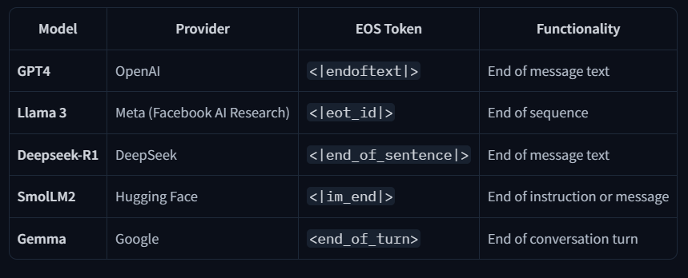

Understanding next token prediction.
LLMs are said to be autoregressive, meaning that the output from one pass becomes the input for the next one. This loop continues until the model predicts the next token to be the EOS token, at which point the model can stop.
In other words, an LLM will decode text until it reaches the EOS. But what happens during a single decoding loop?
While the full process can be quite technical for the purpose of learning agents, here’s a brief overview:
- Once the input text is tokenized, the model computes a representation of the sequence that captures information about the meaning and the position of each token in the input sequence.
- This representation goes into the model, which outputs scores that rank the likelihood of each token in its vocabulary as being the next one in the sequence.
Based on these scores, we have multiple strategies to select the tokens to complete the sentence.
- The easiest decoding strategy would be to always take the token with the maximum score.
You can interact with the decoding process yourself with SmolLM2 in this Space (remember, it decodes until reaching an EOS token which is <|im_end|> for this model):

Messages and Special Tokens
Now that we understand how LLMs work, let’s look at how they structure their generations through chat templates.
Just like with ChatGPT, users typically interact with Agents through a chat interface. Therefore, we aim to understand how LLMs manage chats.

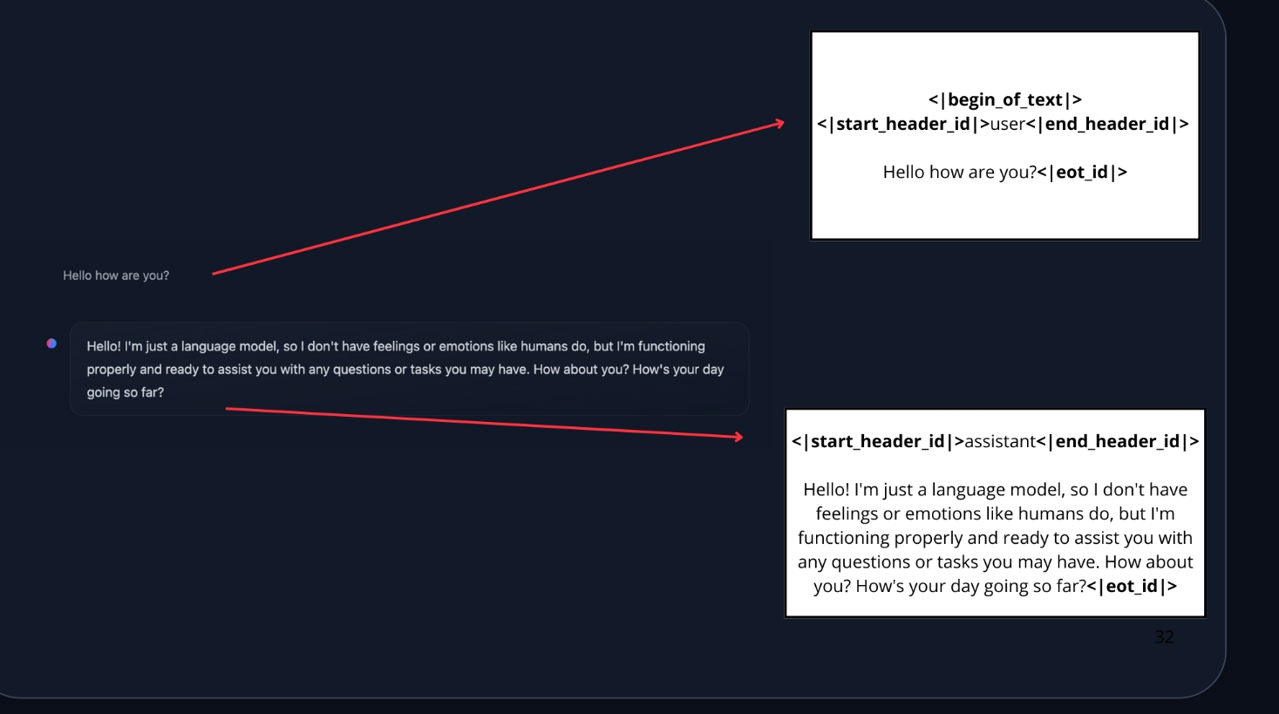
This is where chat templates come in. They act as the bridge between conversational messages (user and assistant turns) and the specific formatting requirements of your chosen LLM. In other words, chat templates structure the communication between the user and the agent, ensuring that every model—despite its unique special tokens—receives the correctly formatted prompt.

System Messages
System messages (also called System Prompts) define how the model should behave. They serve as persistent instructions, guiding every subsequent interaction.
For example:
system_message = {
"role": "system",
"content": "You are a professional customer service agent. Always be polite, clear, and helpful."
}

Conversations: User and Assistant Messages

A conversation consists of alternating messages between a Human (user) and an LLM (assistant).
Chat templates help maintain context by preserving conversation history, storing previous exchanges between the user and the assistant. This leads to more coherent multi-turn conversations.
For example:
conversation = [
{"role": "user", "content": "I need help with my order"},
{"role": "assistant", "content": "I'd be happy to help. Could you provide your order number?"},
{"role": "user", "content": "It's ORDER-123"},
]

Chat-Templates
As mentioned, chat templates are essential for structuring conversations between language models and users. They guide how message exchanges are formatted into a single prompt.

Base Models vs. Instruct Models
Another point we need to understand is the difference between a Base Model vs. an Instruct Model:
- A Base Model is trained on raw text data to predict the next token.
- An Instruct Model is fine-tuned specifically to follow instructions and engage in conversations. For example, SmolLM2-135M is a base model, while SmolLM2-135M-Instruct is its instruction-tuned variant.

To make a Base Model behave like an instruct model, we need to format our prompts in a consistent way that the model can understand. This is where chat templates come in.
ChatML is one such template format that structures conversations with clear role indicators (system, user, assistant). If you have interacted with some AI API lately, you know that’s the standard practice.
It’s important to note that a base model could be fine-tuned on different chat templates, so when we’re using an instruct model we need to make sure we’re using the correct chat template.
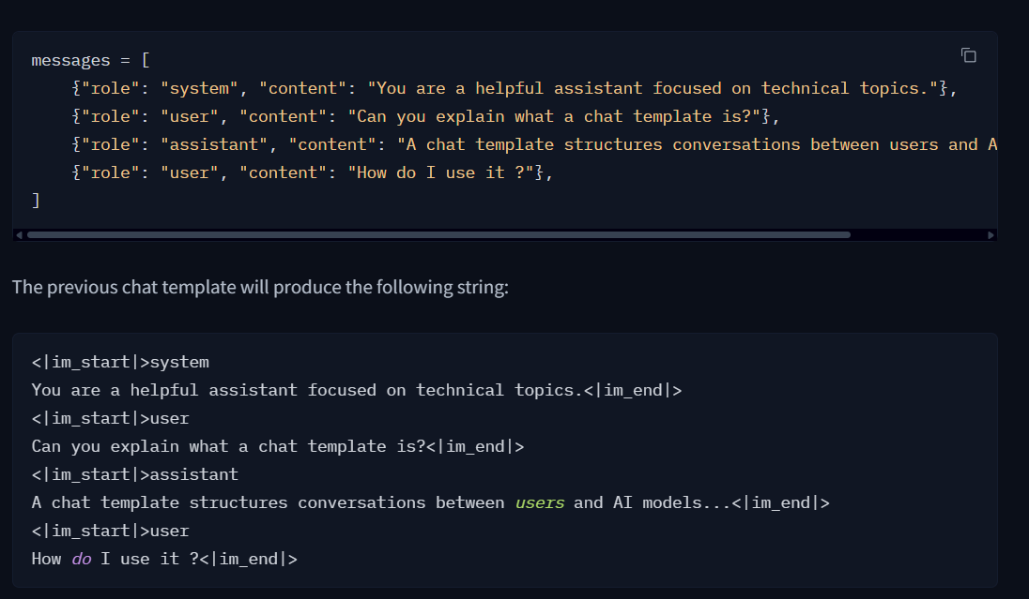

What are AI Tools?
A Tool is a function given to the LLM. This function should fulfill a clear objective.
Here are some commonly used tools in AI agents:
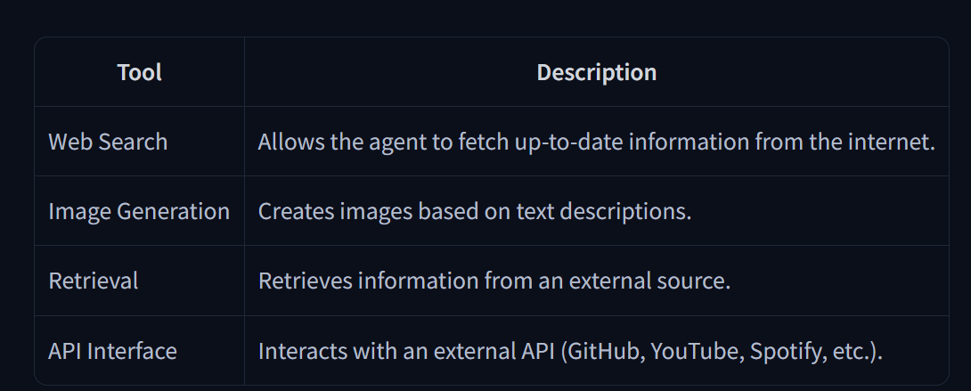

For instance, if you need to perform arithmetic, giving a calculator tool to your LLM will provide better results than relying on the native capabilities of the model.
Furthermore, LLMs predict the completion of a prompt based on their training data, which means that their internal knowledge only includes events prior to their training. Therefore, if your agent needs up-to-date data you must provide it through some tool.
For instance, if you ask an LLM directly (without a search tool) for today’s weather, the LLM will potentially hallucinate random weather.

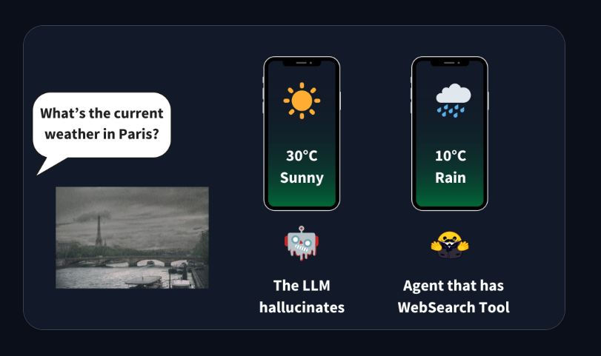

- A Tool should contain:
  - A textual description of what the function does.
  - A Callable (something to perform an action).
  - Arguments with typings.
  - (Optional) Outputs with typings.

How do tools work?
LLMs, as we saw, can only receive text inputs and generate text outputs. They have no way to call tools on their own. When we talk about providing tools to an Agent, we mean teaching the LLM about the existence of these tools and instructing it to generate text-based invocations when needed.
For example, if we provide a tool to check the weather at a location from the internet and then ask the LLM about the weather in Paris, the LLM will recognize that this is an opportunity to use the “weather” tool. Instead of retrieving the weather data itself, the LLM will generate text that represents a tool call, such as call weather_tool(‘Paris’).
The Agent then reads this response, identifies that a tool call is required, executes the tool on the LLM’s behalf, and retrieves the actual weather data.
The Tool-calling steps are typically not shown to the user: the Agent appends them as a new message before passing the updated conversation to the LLM again. The LLM then processes this additional context and generates a natural-sounding response for the user. From the user’s perspective, it appears as if the LLM directly interacted with the tool, but in reality, it was the Agent that handled the entire execution process in the background.

How do we give tools to an LLM?
The complete answer may seem overwhelming, but we essentially use the system prompt to provide textual descriptions of available tools to the model:
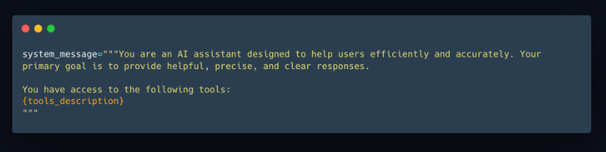

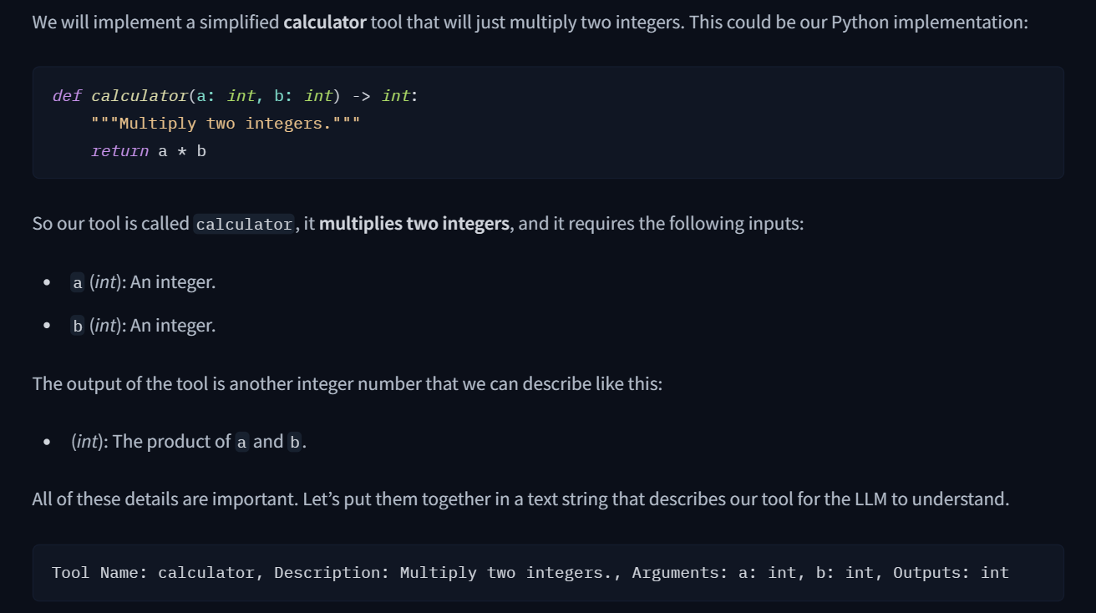
Reminder: This textual description is what we want the LLM to know about the tool.
When we pass the previous string as part of the input to the LLM, the model will recognize it as a tool, and will know what it needs to pass as inputs and what to expect from the output.
If we want to provide additional tools, we must be consistent and always use the same format. This process can be fragile, and we might accidentally overlook some details.
Is there a better way?

Auto-formatting Tool sections
Our tool was written in Python, and the implementation already provides everything we need:
- A descriptive name of what it does: calculator
- A longer description, provided by the function’s docstring comment: Multiply two integers.
- The inputs and their type: the function clearly expects two ints.
- The type of the output.
There’s a reason people use programming languages: they are expressive, concise, and precise.
We could provide the Python source code as the specification of the tool for the LLM, but the way the tool is implemented does not matter. All that matters is its name, what it does, the inputs it expects and the output it provides.
We will leverage Python’s introspection features to leverage the source code and build a tool description automatically for us. All we need is that the tool implementation uses type hints, docstrings, and sensible function names. We will write some code to extract the relevant portions from the source code.
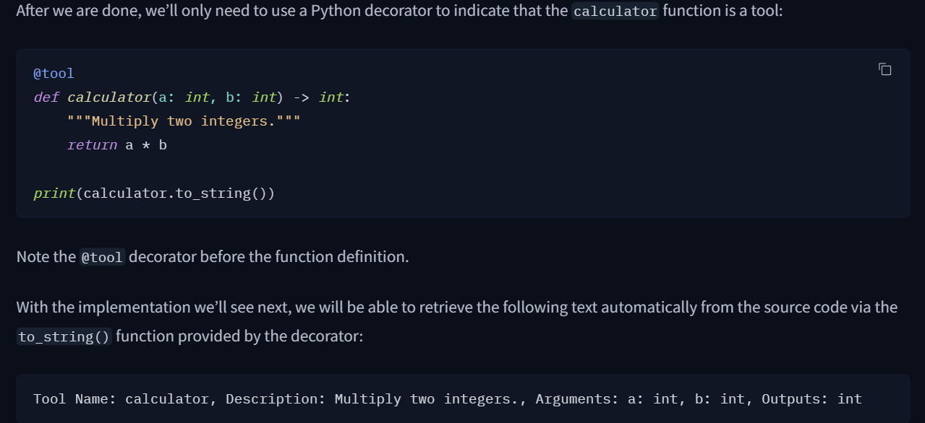

Generic Tool implementation
We create a generic Tool class that we can reuse whenever we need to use a tool.
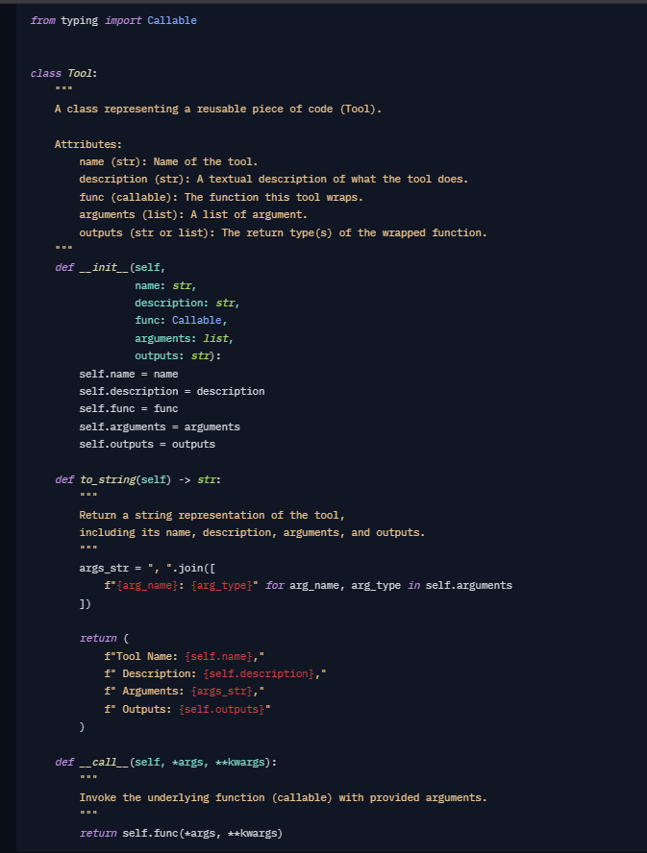
It may seem complicated, but if we go slowly through it we can see what it does. We define a Tool class that includes:
- name (str): The name of the tool.
- description (str): A brief description of what the tool does.
- function (callable): The function the tool executes.
- arguments (list): The expected input parameters.
- outputs (str or list): The expected outputs of the tool.
- __call__(): Calls the function when the tool instance is invoked.
- to_string(): Converts the tool’s attributes into a textual representation.
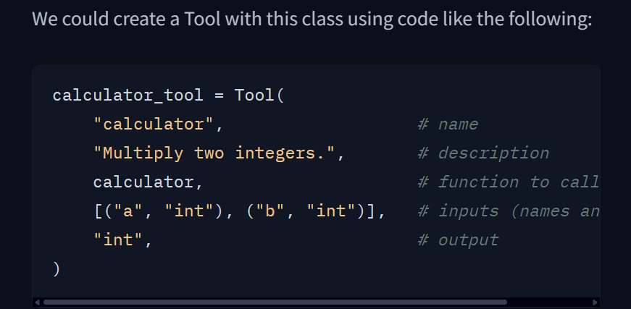

But we can also use Python’s inspect module to retrieve all the information for us! This is what the @tool decorator does.

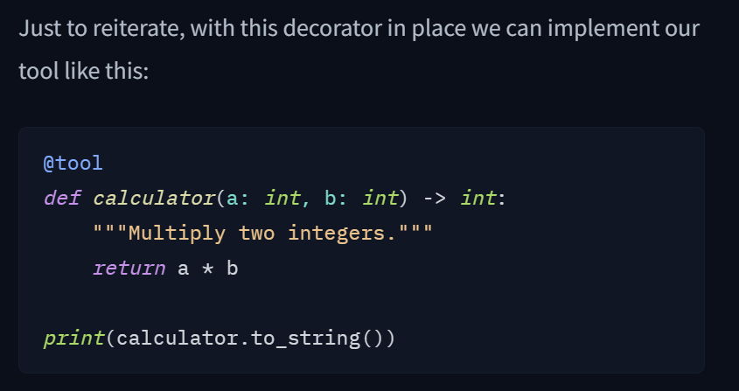

Decorator code:
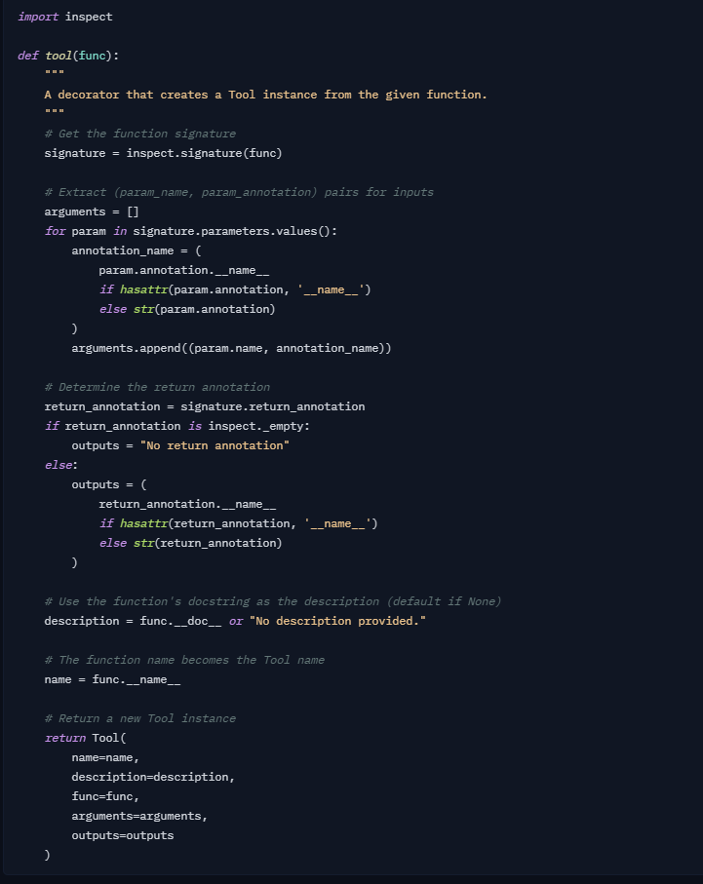

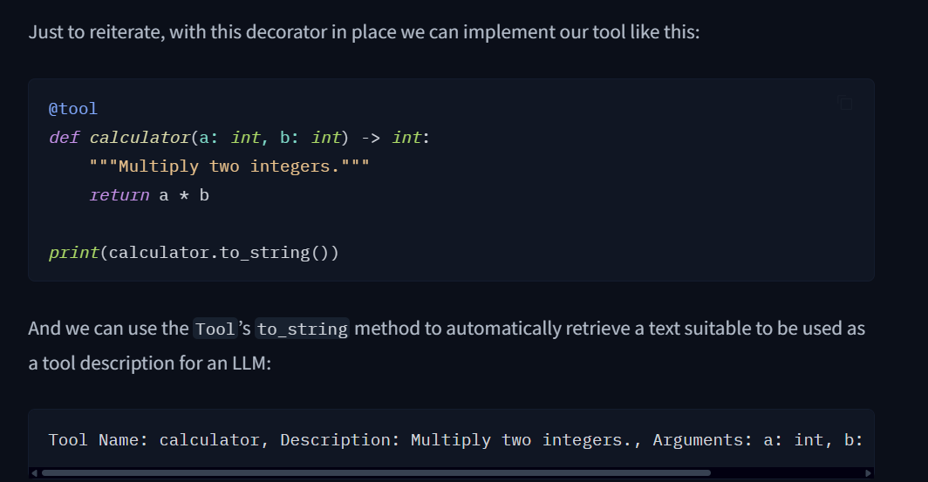

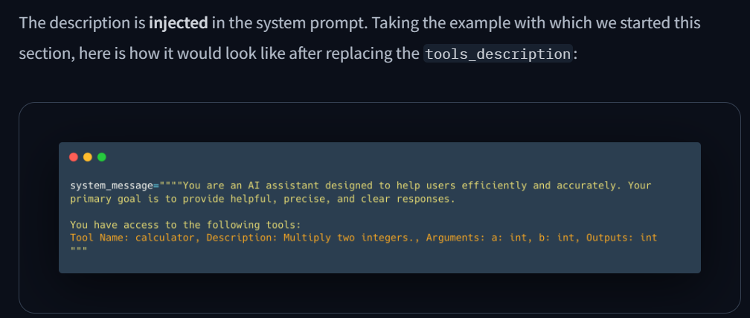

Model Context Protocol (MCP): a unified tool interface
Model Context Protocol (MCP) is an open protocol that standardizes how applications provide tools to LLMs. MCP provides:
- A growing list of pre-built integrations that your LLM can directly plug into
- The flexibility to switch between LLM providers and vendors
- Best practices for securing your data within your infrastructure
This means that any framework implementing MCP can leverage tools defined within the protocol, eliminating the need to reimplement the same tool interface for each framework.

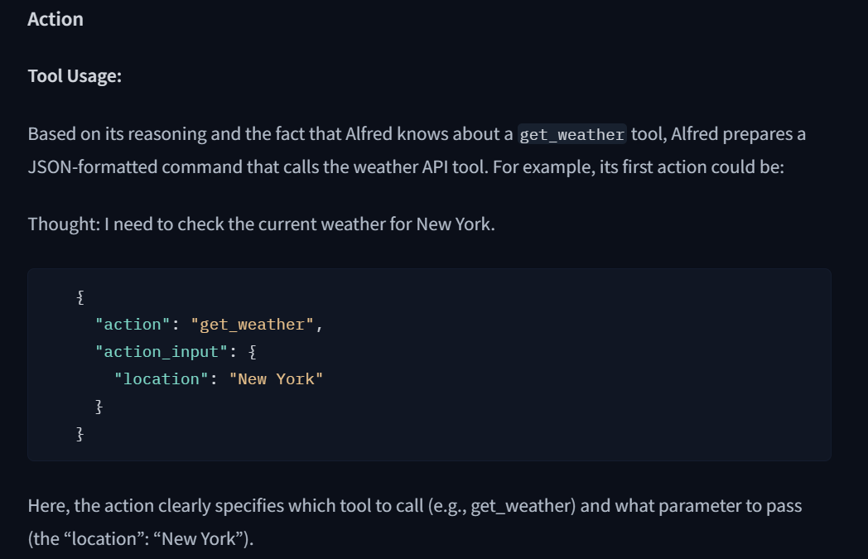

Thought: Internal Reasoning and the ReAct Approach
In this section, we dive into the inner workings of an AI agent—its ability to reason and plan. We’ll explore how the agent leverages its internal dialogue to analyze information, break down complex problems into manageable steps, and decide what action to take next. Additionally, we introduce the ReAct approach, a prompting technique that encourages the model to think “step by step” before acting.

Thoughts represent the Agent’s internal reasoning and planning processes to solve the task.
This utilises the agent’s Large Language Model (LLM) capacity to analyze information when presented in its prompt.
Think of it as the agent’s internal dialogue, where it considers the task at hand and strategizes its approach.
The Agent’s thoughts are responsible for accessing current observations and decide what the next action(s) should be.
Through this process, the agent can break down complex problems into smaller, more manageable steps, reflect on past experiences, and continuously adjust its plans based on new information.
Here are some examples of common thoughts:
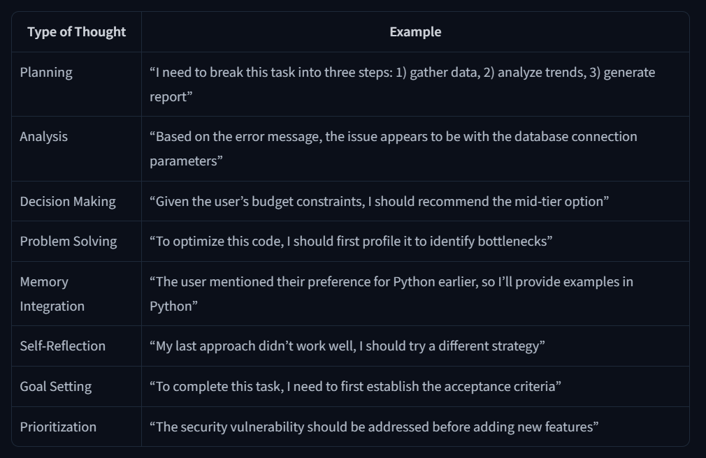

The ReAct Approach
A key method is the ReAct approach, which is the concatenation of “Reasoning” (Think) with “Acting” (Act).
ReAct is a simple prompting technique that appends “Let’s think step by step” before letting the LLM decode the next tokens.
Indeed, prompting the model to think “step by step” encourages the decoding process toward next tokens that generate a plan, rather than a final solution, since the model is encouraged to decompose the problem into sub-tasks.
This allows the model to consider sub-steps in more detail, which in general leads to less errors than trying to generate the final solution directly.

